1. Find the number of student in CSE second year.

select count(roll_no) from student where semester='SEM3' and deptcode='CSE';



1. Find the number of students whose marks of any subject is available.

select count(distinct(rollno)) from result;



1. Find total number of faculty.

select count(fid) from faculty;

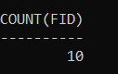

1. Find the 5th semester student(s) who got maximum marks in a subject.

select rollno,Marks from result where marks in (select max(marks) from result group by Sub_code) and sub_code like '%50_';

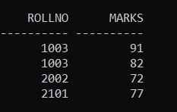

1. Find the roll number of a student who got maximum marks in CS501.

select rollno from result where marks in (select max(marks) from result group by Sub_code)and sub_code='CS501';



1. Display average marks of CS502.

select avg(marks) from result where sub_code='CS502' group by sub_code;



1. Find the number of students in each department with their department code.

select deptcode,student_allotted from department;

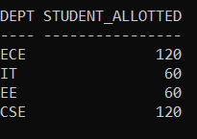

1. Find the number of students in each department with their department name.

select deptname,student_allotted from department;

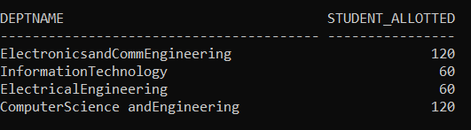

1. Find the Department with more than three faculties.

select deptcode from (select deptcode,count(teacher) as num from subject group by deptcode) where num>3;



1. Find the student name and roll no who get more than 80 in at least two subject.

select name,rollno from student,(select rollno,count(sub_code) as subnum from result where marks>80 group by rollno) where subnum>=2 and rollno=roll_no;



1. Find the student name and roll no who get more than 70 in average.

select name,rollno from student,(select rollno,avg(marks) as average from result group by rollno) where average>70 and rollno=roll_no;

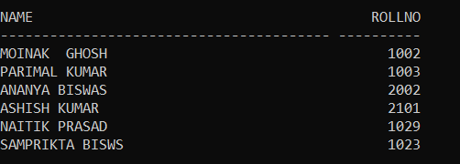

1. Display number of subject semester wise in dept CSE.

select semester,count(subjectcode) from subject where deptcode='CSE' group by semester;

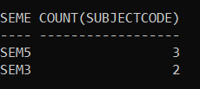

1. Find the department name with maximum number of student.

select deptname from department where student_allotted=(select max(student_allotted) from department);



1. Find the second highest marks of the result table.

select max(marks) as marks from result where marks<(select max(marks) from result);



1. Find the students name who has got highest marks, subject-wise

select name,sub_code from result,student where marks in (select max(marks) from result group by Sub_code) and rollno=roll_no;

